Build Out Line Rules
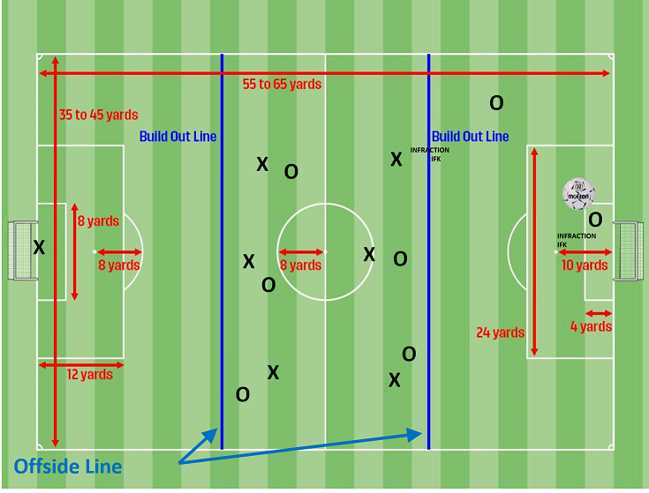
- The spirit of this rule is to encourage the C and D Division teams to learn how to play the ball forward from the first third. Traditionally keepers have been able to just punt the ball across the midway line which was a detriment to the players learning how to progress the ball forward from defense to mid field to the attackers.
- When the goalkeeper (Team O) has the ball in his/her hands during play, the opposing team (Team X) must move behind the build-out line until the ball is released from the goalkeeper's possession and crosses the penalty area.
- Once the opposing team is behind the build-out line, the goalkeeper can release the ball by passing (NOT dribbling), throwing, or rolling the ball to a teammate who is on his/her side of the build-out line or beyond the build-out line.
- Section 1R has clarified that the goalkeeper may roll (not bounce) the ball and then pass the ball to a teammate on their side of the build out line.
- PUNTS and DROP KICKS are not allowed from the keeper.
- After the ball is released from the goalkeeper's possession and crosses the penalty area, the opposing team may cross the build-out line and play resumes as normal.
- The goalkeeper releasing the ball from possession or the player taking the goal kick does not have to wait for the opposing players to move behind the build-out line.
- The play from the goalkeeper or from the goal kick can be played to a teammate beyond the build-out line.
- On Goal Kicks, the ball must be kicked and cross the penalty area before the opposing team can cross the build out line to attack the ball.
- The build-out line shall be used as the line to determine offside. Players cannot be penalized for an offside offense between the halfway line and the build-out line.
- Players can be penalized for an offside offense between the build-out line and goal line.

